

VARIABLE NAMES: LEGAL & ILLEGAL

Assignment # 4

JAVASCRIPT

VARIABLE NAMES: Legal & Illegal | JAVASCRIPT

1. Declare 3 variables in one statement.
2. Declare 5 legal & 5 illegal variable names.
3. Display this in your browser
   1. A heading stating “Rules for naming JS variables”

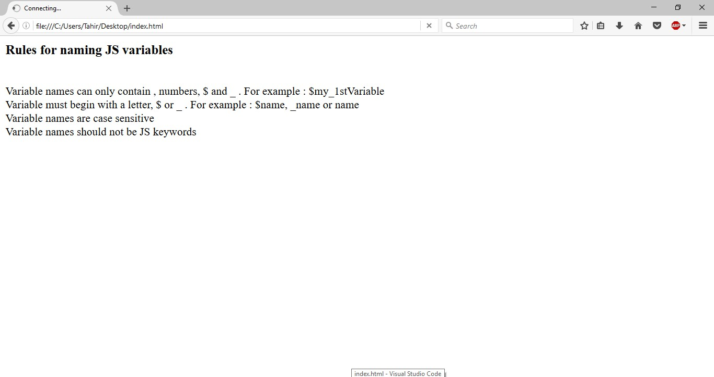

1. Variable names can only contain , ,

and .

For example **$my_1stVariable**

1. Variables must begin with a , or

. For example **$name, _name** or **name**

1. Variable names are case
2. Variable names should not be JS

**-- END --**

vPage **1** of **1**

